Strand B:
Program Development and Management/Information Access and Delivery

Strand B. Program Development and Management/ Information Access and Delivery
(Competencies 7-9)

The documentation that you prepare for Strand B will allow independent reviewers to make decisions related to Competencies 7-9:

- The librarian-teacher models and promotes collaborative planning.
- The librarian-teacher organizes and manages the library in accordance with established written policies and procedures.
- The librarian-teacher manages the educational setting in a manner that promotes positive student behavior and a safe and healthy environment.

If a candidate for licensure advancement meets in one or some of the strands, but not in all of them, the teacher's score(s) of "meets standards" may be retained for a period of two calendar years. Any resubmission of a PDD during that two-year period need only address those strands rated "does not meet standards" in order to determine a final passing score for all strands for licensure advancement.

If your scores of meets have exceeded the period of two calendar years from the announcement of the scores they are no longer valid.

NM Professional Development Dossier for Librarian-Teachers
Strand B: Program Development and Management/Information Access and Delivery, 8.2019

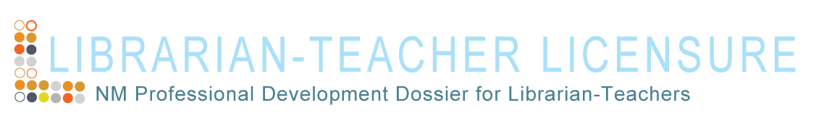

Strand B: Program Development and Management/Information Access and Delivery

Before completing all sections of this strand, carefully read and follow directions in the Requirements and Guidelines for the Preparation of the New Mexico Professional Development Dossier for Librarian- Teachers, 1st Edition.

I. Introduction: This section of your documentation introduces your library change/improvement efforts.
Provide the following information for your library change effort:
A. Grade level(s) of the school: | Enter grade level
B. Number of students in the school: | Enter nmber of students
C. The area of your library services that could be more responsive to user needs: | Enter area
D. Why you have identified this feature for enhancement (e.g., books per student, average age of collection): | Enter rationale for your choice

E. A brief summary of the steps involved in implementing the change: | Enter brief summary
F. The kinds of evidence you will use to illustrate the process: | Enter evidence

II. Explanation of Library Change Process: This section explains in detail how you implemented the reform.
A. Why did you select this area to enhance in the library?
Enter response (500 word maximum)

B. How did you gather the evidence?
Click to respond (350 word maximum)

C. What does the evidence show about your approach to improving service delivery in the library?
Click to respond

D. How did the improved service delivery impact other areas of library management?
Click to respond (500 word maximum)

E. How did you know that the change made a difference?
Click to respond (500 word maximum)

F. How did you communicate with and involve the school community?
Click to respond (500 word maximum)

III. Evidence of the Change Process: This section of your documentation provides concrete evidence
of what you explain in Section II.
Example 1
Click to enter evidence

Example 2
Click to enter evidence

Example 3

Click to enter evidence

Example 4
Click to enter evidence

Example 5
Click to enter evidence

IV. Resources: (Maximum of 4 resources)
Resource 1
Follow instructions provided in Strand A, Section IV. Resources of the Requirements & Guidelines for Preparation of the New Mexico Librarian-teacher Professional Development Dossier.
Click to insert the label information for this type of resource and/or a brief description of the material.
Click to enter resource

Resource 2
Follow instructions provided in Strand A, Section IV. Resources of the Requirements & Guidelines for Preparation of the New Mexico Librarian-teacher Professional Development Dossier.
Click to insert the label information for this type of resource and/or a brief description of the material.
Click to enter resource

Resource 3
Follow instructions provided in Strand A, Section IV. Resources of the Requirements & Guidelines for Preparation of the New Mexico Librarian-teacher Professional Development Dossier.
Click to insert the label information for this type of resource and/or a brief description of the material.
Click to enter resource

Resource 4
Follow instructions provided in Strand A, Section IV. Resources of the Requirements & Guidelines for Preparation of the New Mexico Librarian-teacher Professional Development Dossier.
Click to insert the label information for this type of resource and/or a brief description of the material.
Click to enter resource

